Mohamed LOUNICI  Project Engineer  Paris | 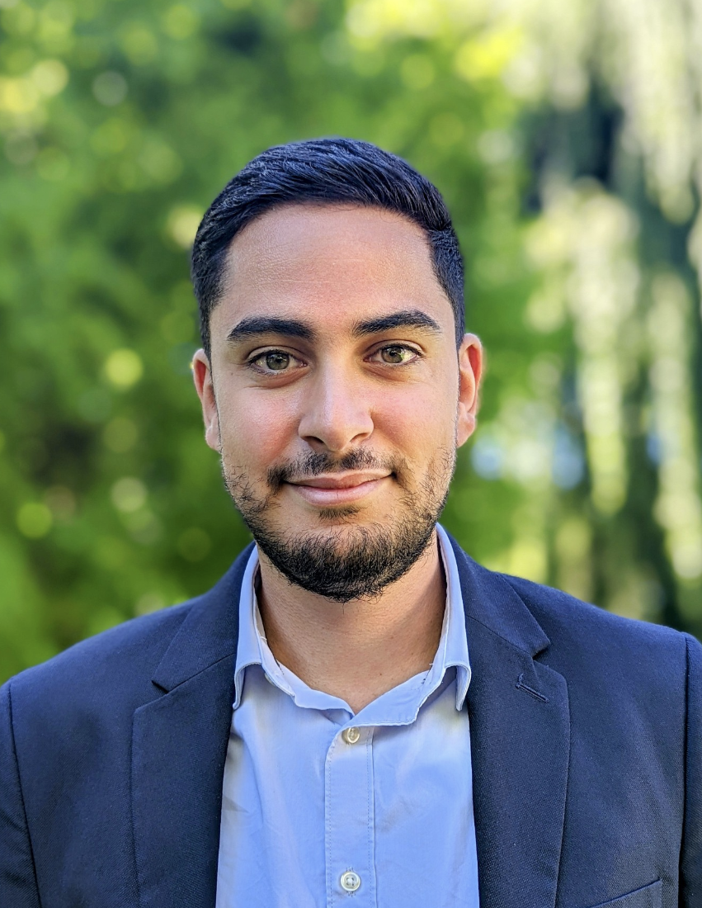 |  |  | Year of birth: 1996  Nationality: French  Language(s): English, Spanish

AREAS OF EXPERTISE
Project Engineer
- Design of Urban development project: project management, production coordination.
- Coordination and BIM management of urban projects.
- Prospecting and technical-financial preparation of offers.
PROFESSIONAL EXPERIENCE
Mohamed joined setec International in July 2021.
He has 6 years of experience in the design and realization of urban development projects. He carries out technical studies from design phases until the end of the realization of the works.
EDUCATIONAL BACKGROUND
2015 – 2018
Engineering degree - Ecole des Ingénieurs de la Ville de Paris (School of Engineers of the City of Paris)

MAIN TASKS
Urban development
KSPF – King Salman Park, Riyadh (Saudi Arabia) (2021/Ongoing)
Project Manager / Coordination of Utilities Team

BAPCO – Awali Township Masterplan (Bahrain) (2023/Ongoing)
Project Engineer / Utilities design

KSFD – King Salman Financial District Masterplan, Riyadh (Saudi Arabia) (2023/2024)
Project Manager / Coordination of Utilities Team

VILLE DE PARIS - Project management for cycling facilities (2021/Ongoing)
Project Engineer

RATP - Project management for the redevelopment of the outdoor spaces of the train station of Antony (2020/Ongoing)
Project Engineer

PARIS METROPOLE AMENGEMENT (PMA) - (Former experience) – Urban development and Utilities coordination of ZAC Saint Vincent de Paul, Paris 14e
Project Manager / Coordination of design team

GRAND PARIS SEINE OUEST (GPSO) (Former experience) – Development of Place Jules Guesde, Boulogne-Billancourt
Project Manager / Coordination of design team

VILLE DE VIROFLAY (Former experience) – Requalification of the Marquette district, Viroflay
Project Engineer

HAROPA - Project management for the redevelopment of the port of Suffren
Project Engineer

GRAND PARIS AMENAGEMENT (GPA) (Former experience) – Utilities master plan as part of the development of Triangle de Gonesse, Gonesse
Project Engineer

GRAND PARIS SUD (GPS) (Former experience) – Utilities master plan as part of the ANRU 2 project at Grande Borne, Grigny
Project Engineer

COMMUNAUTÉ D’AGGLOMÉRATION DE SAINT-QUENTIN-EN-YVELINES (CASQY) (Former experience) – Development of a cycle path RD36, Montigny-le-Bretonneux (Site supervision)
Project Engineer

BIM Management
KSPF – King Salman Park, Riyadh (Saudi Arabia) (2021-On going)
BIM Management of Utilities production

RATP - Project management for the redevelopment of the outdoor spaces of the train station of Antony (2020/Ongoing)
BIM Management of urban development project

PARIS METROPOLE AMENGEMENT (PMA) - (Former experience) – Urban development and Utilities coordination of ZAC Saint Vincent de Paul, Paris 14e
BIM Management of urban development project

LANGUAGE SKILLS
- English: Confirmed
- Spanish: Intermediate

